POWER BI – VISUALIZE TO REALIZE
Superstore Sales Dashboard

1. Introduction
Microsoft Power BI is a powerful data visualization and business intelligence tool used to analyze large amounts of data and present the results in the form of interactive reports and dashboards. In this project, the Superstore Sales Dataset is used to analyze sales, profit, orders, quantity and regional performance.
The main purpose of this project is to transform raw sales data into meaningful information using Power Query, DAX measures, data modeling and different visualizations. The final dashboard provides an easy way to understand the overall business performance and compare sales and profit across different categories, years and regions.

2. Importing the Dataset
The first step of the project is to import the Superstore Sales dataset into Microsoft Power BI. Power BI supports different types of data sources such as Excel, CSV, SQL Server and other databases.
For this project, the Superstore Sales data is loaded into Power BI. After importing the dataset, the table appears in the Data pane. The main source table used in this project is named samplesuperstore.
The imported dataset contains different columns related to orders, customers, products, sales, profit, quantity, category and region. These columns are used for further data preparation and analysis.
Steps:
- Open Power BI Desktop.
- Select Home → Get Data.
- Select the required dataset.
- Choose the samplesuperstore table.
- Click Load.
- Verify that the table appears in the Data pane.

3. Data Cleaning and Transformation
After importing the dataset, the next step is to prepare the data for analysis. Data cleaning is important because incorrect data types, unwanted spaces or inconsistent values can affect the accuracy of the report.
Power BI provides Power Query Editor for performing data cleaning and transformation operations. It allows users to modify the dataset without changing the original source file.
In this project, the columns are checked for correct data types. Date columns are assigned suitable date formats, and text fields are cleaned where necessary. Year and other date-related fields can also be prepared for creating time-based visualizations.
Steps:
- Select Home → Transform Data.
- Power Query Editor will open.
- Check the column names.
- Check and correct the data types.
- Set date columns to Date format.
- Remove unnecessary spaces from text fields.
- Create required date/year fields.
- Select Close & Apply.

4. Creating DAX Measures
DAX stands for Data Analysis Expressions. It is a formula language used in Power BI to create calculations and measures from the available data.
In this project, several measures are created to calculate important business metrics. These measures are later used in KPI cards and charts. Measures are useful because their values can change dynamically when the user applies filters or slicers.
The following measures are created:
Total Sales = SUM(samplesuperstore[Sales])
This measure calculates the total sales amount.
Total Profit = SUM(samplesuperstore[Profit])
This calculates the total profit earned from the sales.
Total Orders = DISTINCTCOUNT(samplesuperstore[Order ID])
This counts the number of unique orders.
Total Quantity = SUM(samplesuperstore[Quantity])
This calculates the total quantity of products sold.
Average Sales = AVERAGE(samplesuperstore[Sales])
This calculates the average sales value.
Profit Margin % = DIVIDE([Total Profit], [Total Sales], 0)
This calculates the profit margin by dividing total profit by total sales.
Steps:
- Go to Modeling.
- Click New Measure.
- Enter the DAX formula.
- Press Enter.
- Repeat the process for the remaining measures.
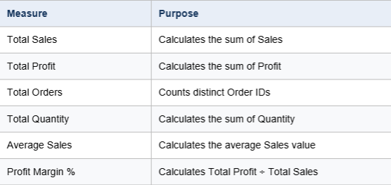

5. Creating KPI Cards
KPI cards are used to display important numerical information in a simple and easy-to-read format. They provide an overview of the business performance without requiring the user to analyze a chart.
In this project, six KPI cards are created using the DAX measures. The cards display Total Sales, Total Profit, Total Orders, Total Quantity, Average Sales and Profit Margin %.
These cards are placed at the top of the dashboard so that the main business metrics can be viewed immediately.

KPI Cards Used:
- Total Sales – Shows the overall sales value.
- Total Profit – Shows the total profit or loss.
- Total Orders – Shows the number of unique orders.
- Total Quantity – Shows the total number of products sold.
- Average Sales – Shows the average sales value.
- Profit Margin % – Shows the relationship between profit and sales.
Steps:
- Select the Card visual.
- Drag the required measure into the card.
- Repeat for all six measures.
- Arrange the cards neatly at the top of the dashboard.
- Format the cards if required.

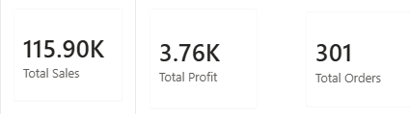
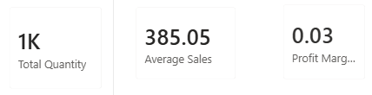

6. Creating Total Sales by Category Chart
The Total Sales by Category chart is used to compare the sales performance of different product categories.
The Superstore dataset contains categories such as Furniture, Office Supplies and Technology. By using a chart, it becomes easier to compare the sales contribution of each category.
Steps:
- Select a Column Chart visual.
- Add Category to the X-axis.
- Add Total Sales to the Y-axis.
- Adjust the chart size.
- Add a suitable title.
This visualization helps in understanding how sales are distributed among different product categories.
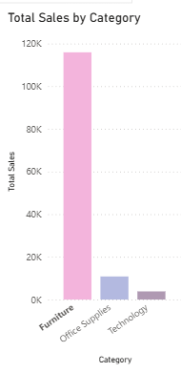

7. Creating Total Sales by Year Chart
A time-based visualization is useful for understanding how sales change over different years.
In this project, a Line Chart is used to display Total Sales by Year. The year field is placed on the X-axis and Total Sales is placed on the Y-axis.

Steps:
- Select a Line Chart.
- Add Order Year to the X-axis.
- Add Total Sales to the Y-axis.
- Format the chart.
- Give the chart an appropriate title.
The resulting chart makes it easier to observe changes in sales over the available years.
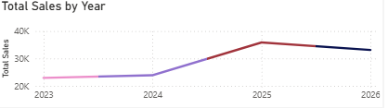

8. Creating Total Profit by Region Chart
The Total Profit by Region visualization compares the profit generated by different geographical regions.
The regions in the Superstore dataset include Central, East, South and West. Region is placed on the X-axis and Total Profit is placed on the Y-axis.
Steps:
- Select a column/bar chart.
- Add Region to the X-axis.
- Add Total Profit to the Y-axis.
- Format the chart.
- Add a suitable title.
This chart helps the user compare the profitability of different regions.
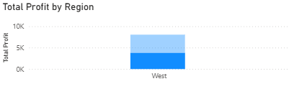
9. Creating Region Slicer
A slicer is an interactive filtering tool in Power BI. It allows the user to select a particular value and automatically filter the related visuals on the report page.
In this project, a Region Slicer is created. It contains the different regions such as Central, East, South and West.
When a region is selected, the dashboard visuals can update according to the selected region.
Steps:
- Select the Slicer visual.
- Drag the Region field into the slicer.
- Resize the slicer.
- Place it in a suitable position on the dashboard.
- Test the slicer by selecting different regions.
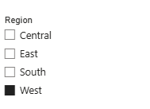

10. Creating SalesTable
To demonstrate data modeling, a separate calculated table named SalesTable is created.
This table contains important fields such as Order ID, Sales, Profit and Region from the original samplesuperstore table.
Steps:
- Go to Modeling.
- Select New Table.
- Enter the following DAX formula:
SalesTable = SELECTCOLUMNS(
samplesuperstore,
"Order ID", samplesuperstore[Order ID],
"Sales", samplesuperstore[Sales],
"Profit", samplesuperstore[Profit],
"Region", samplesuperstore[Region]
)
- Press Enter.
- Check the Data pane for the newly created SalesTable.

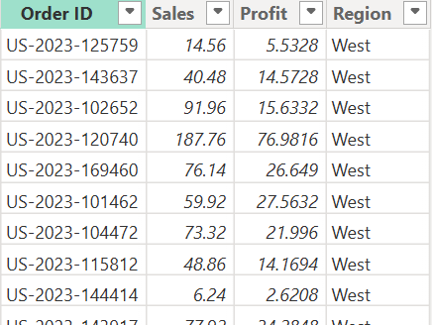
11. Creating RegionTable
A second table named RegionTable is created to contain the unique region values.
The DISTINCT function is used so that each region appears only once in the table. This table can then be used as the one-side table in the relationship.
Steps:
- Go to Modeling → New Table.
- Enter:
RegionTable = DISTINCT(
SELECTCOLUMNS(
samplesuperstore,
"Region", samplesuperstore[Region]
)
)
- Press Enter.
- Check that RegionTable appears in the Data pane.
The table contains unique region values such as Central, East, South and West.
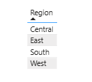

12. Creating Relationship Between Tables
Data modeling allows different tables to work together. In this project, SalesTable and RegionTable are connected using the common Region field.
The relationship is created between:
SalesTable[Region] → RegionTable[Region]
Since SalesTable can contain the same region multiple times while RegionTable contains each region only once, the relationship is Many-to-One (*:1).
Steps:
- Open Model View.
- Locate SalesTable.
- Locate RegionTable.
- Drag SalesTable[Region].
- Drop it onto RegionTable[Region].
- Check the relationship settings.
- Set Many-to-One (*:1).
- Set Cross-filter direction → Single.
- Keep the relationship active.
- Click Save/OK.
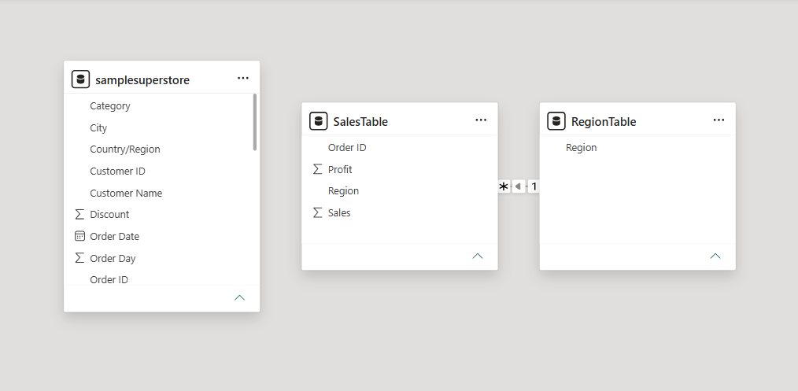
14. Designing the Final Dashboard
After creating the measures, charts, slicer and data model, all the visuals are arranged on a single report page.
The dashboard is given the title “Superstore Sales Dashboard”. The KPI cards are placed at the top, while the charts are arranged below them. The Region slicer is positioned on the side for interactive filtering.
The dashboard provides a simple and interactive view of the Superstore sales data.
Dashboard contains:
- Total Sales Card
- Total Profit Card
- Total Orders Card
- Total Quantity Card
- Average Sales Card
- Profit Margin Card
- Total Sales by Category
- Total Sales by Year
- Total Profit by Region
- Region Slicer
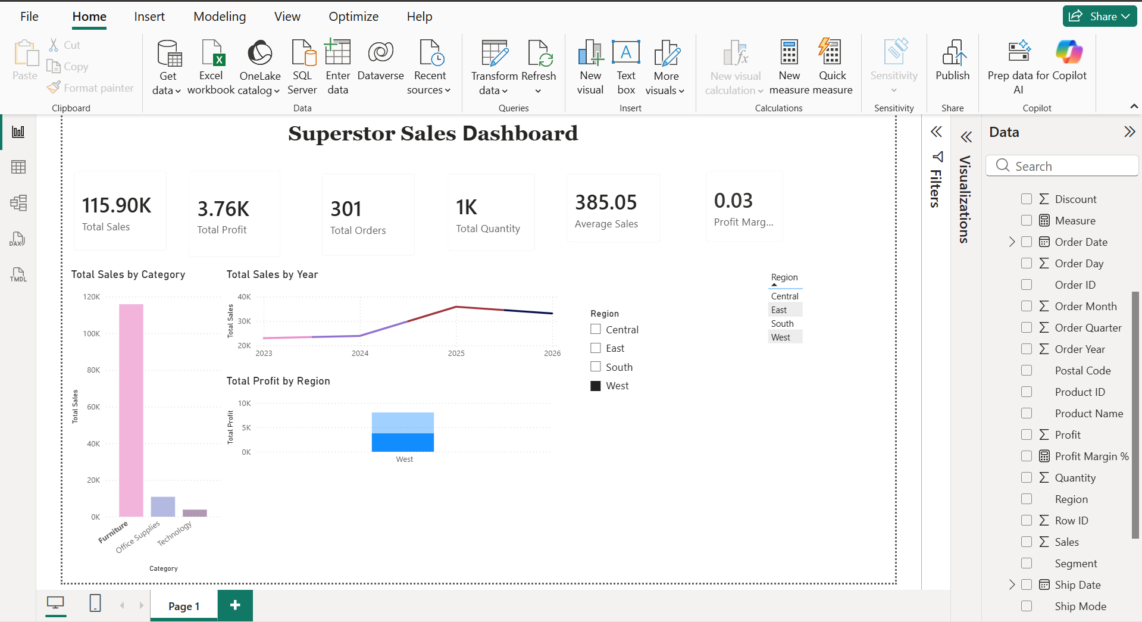
15. Final Result
The final Power BI report successfully converts the Superstore Sales dataset into an interactive dashboard. DAX measures are used to calculate important business metrics, while charts provide visual comparisons of sales and profit.
The Region slicer allows users to interact with the report and examine the data based on different regions. The data model demonstrates how two related tables can be connected using a common field.
The completed dashboard provides a clear and organized representation of the Superstore sales information and demonstrates the use of data preparation, DAX, data modeling and visualization in Power BI.
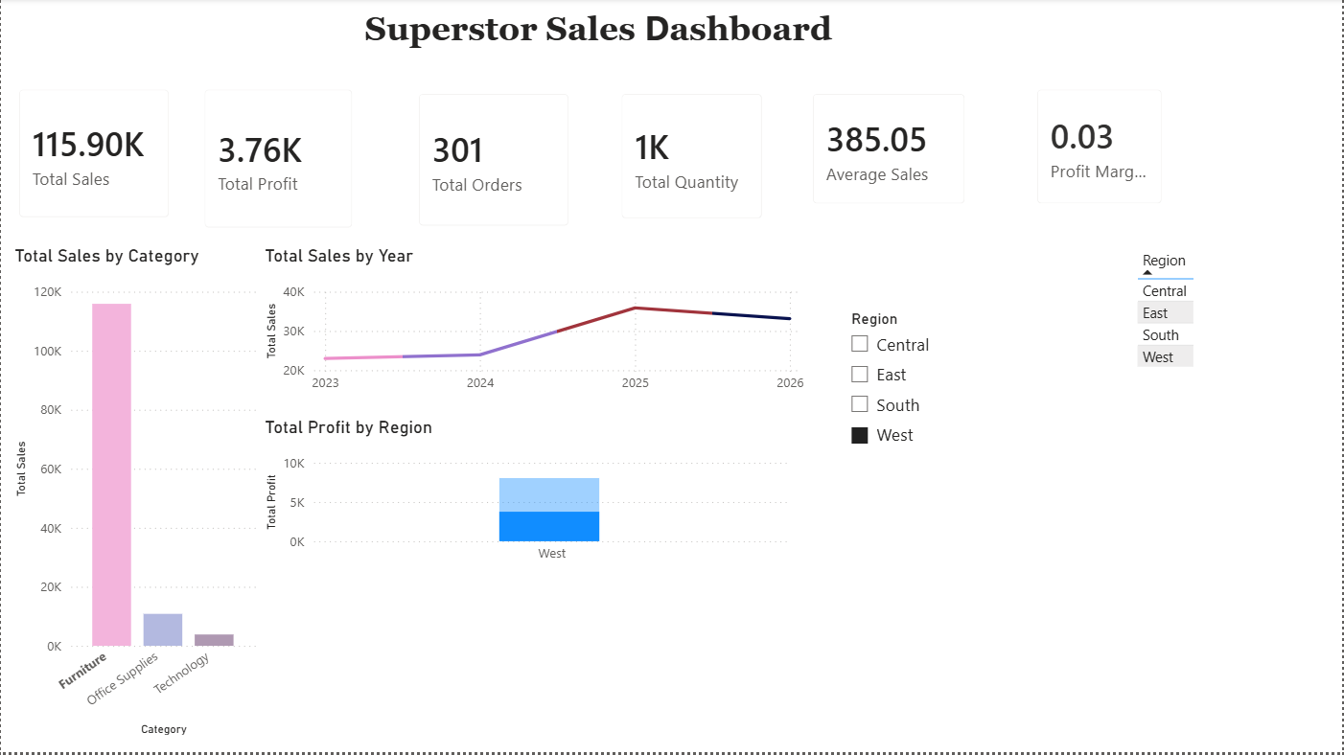

16. Conclusion
This project helped in understanding the complete process of creating a Power BI report, starting from importing and preparing the dataset to creating DAX measures, relationships and interactive visualizations. The final Superstore Sales Dashboard presents important sales and profit information in a clear and user-friendly manner.

